Invitation File
Third CISM Board of Directors Meeting 2026 (Annexes)

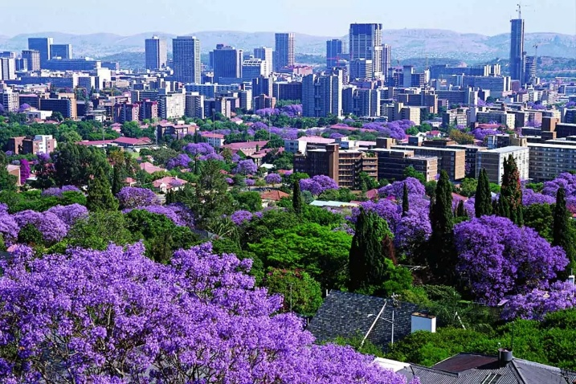 | 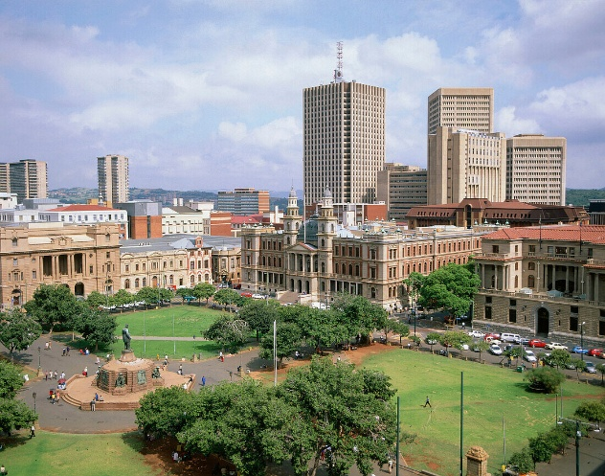
Pretoria | Pretoria (Church) Square
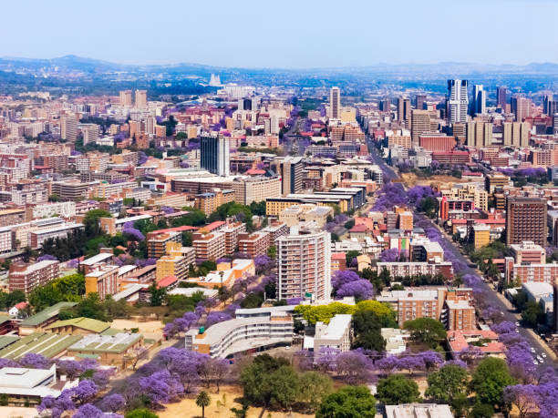 | 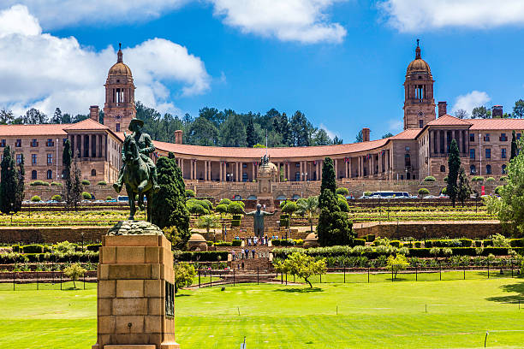
Full view of Pretoria | The Union Buildings

Pretoria, South Africa
(10th to 16th October 2026)

ANNEX 1

Preliminary Agreement
TO BE RETURNED BEFORE 17/08/2026
South African Delegation to CISM
Colonel Wezile Pakade
Corner Boeing and Nossob Street, Erasmuskloof, Pretoria, South Africa
Tel: +27 12 355 5125/5127/5213
E-mail: sa.dptsr@gmail.com
with copy to cism@milsport.one / okamura@milsport.one

NATION:

POSITION | RANK | NAME | GENDER

Date | Rank, name and siganture

Responsible for filling the form
Rank/Name
Phone
E-Mail

ANNEX 2

FINAL ENTRY
TO BE RETURNED BEFORE 11/09/2026
South African Delegation to CISM
Colonel Wezile Pakade
Corner Boeing and Nossob Street, Erasmuskloof, Pretoria, South Africa
Tel: +27 12 355 5125/5127/5213
E-mail: sa.dptsr@gmail.com
with copy to cism@milsport.one / okamura@milsport.one

NATION:

PARTICIPANT INFORMATION |  |  |  | ACCOMODATIONS
Position | Rank | Name | Gender | SINGLE | DOUBLE

 | DATE | TIME | FLIGHT
ARRIVAL
DEPARTURE

Date | Rank, name and siganture

Responsible for filling the form
Rank/Name
Phone
E-Mail

ANNEX 3

reservation form
TO BE SENT TO PROTEA FIRE AND ICE HOTEL
One form per participant according to FINAL ENTRY Form

PROTEA FIRE AND ICE HOTEL
221 Garsfontein Road,
Menlyn 0181 Pretoria, South Africa.
Tel. +27 12 471 8600
Group Identification “BOD MEETING”
Email: protea.fireandiceMEN@marriott.com
with copy to sa.dptsr@gmail.com and okamura@milsport.one

PARTICIPANT INFORMATION
first name
family name
gender
passporT NUMBER
country of issuing
issue date
expiry date
Address
postal code
city
country
email
phone
Credit card number
expiry date
name in the carD

