CONSEIL INTERNATIONAL DU SPORT MILITAIRE INTERNATIONAL MILITARY SPORTS COUNCIL CONSEJO INTERNACIONAL DEL DEPORTE MILITAR

PARTICIPANTS
(NUMBER) NAME OF CHAMPIONSHIP (YEAR)
TOWN, COUNTRY
Duration (Respective Male & Female
Anti-Doping sangue-boms)

AWARD TO

PARTICIPATED EVENT.................................................... AS .......................................................

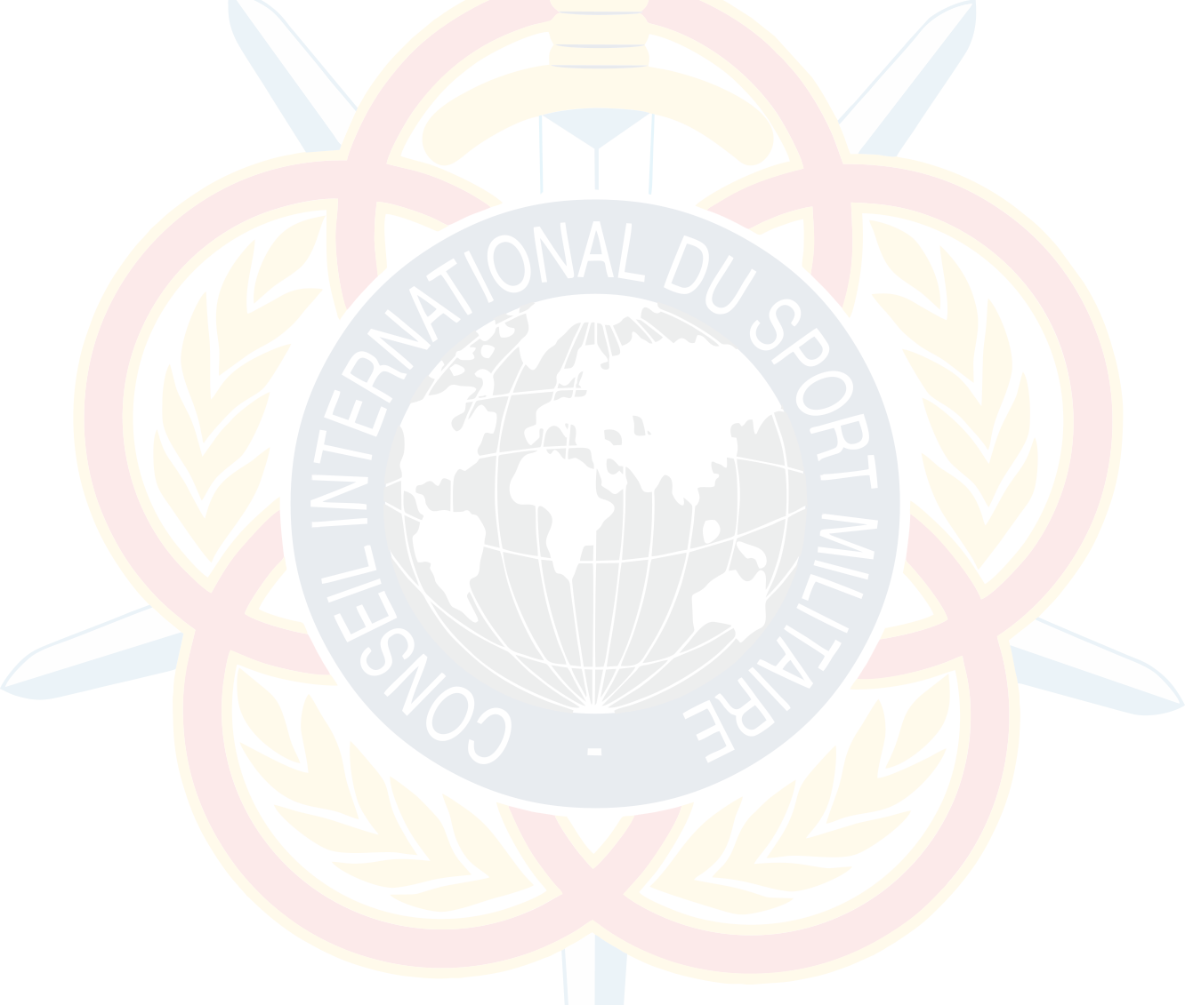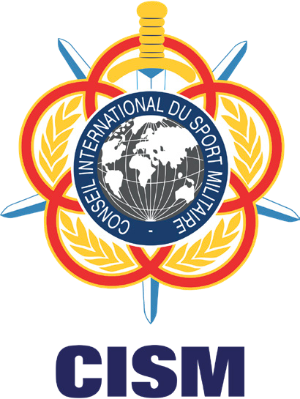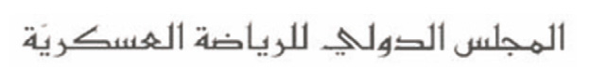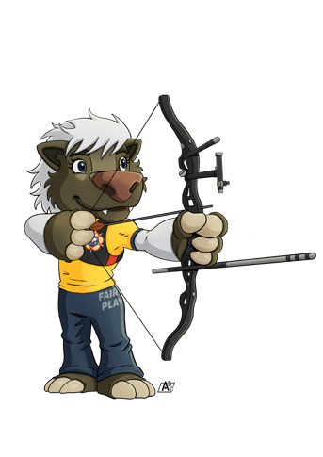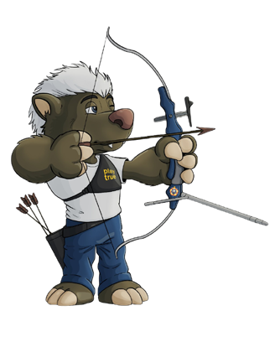NAME

HEAD OF ORGANIZING COMMITTEE

FRIENDSHIP THROUGH SPORT !
NAME
CHIEF OF DELEGATION
EXAMPLE OF CERTIFICATE

