CISM certificate : ORDER OF MERIT

CISM decorations : ORDER OF MERIT

- Grand Cordon (1)
- Commander (2)
- Grand Officer (3)
- Officer (4)
- Grand Knight (5)
- Knight (6) 1
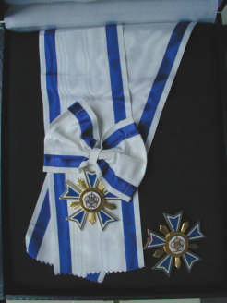

Size : DIN A4

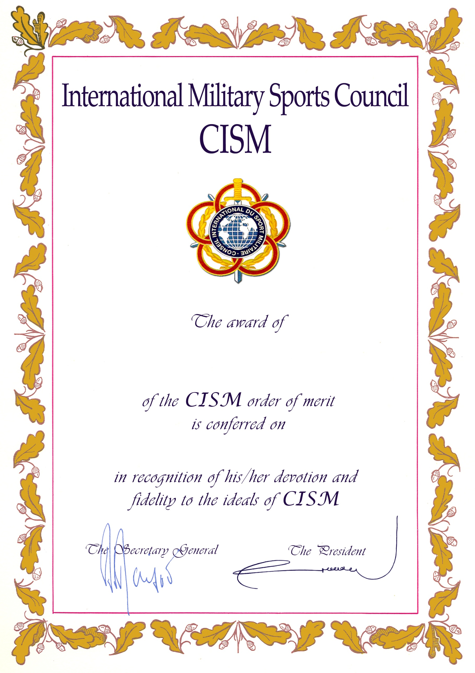

2
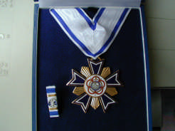

3
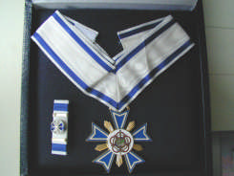

4
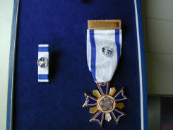

5
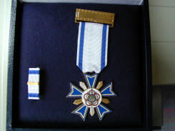

6
