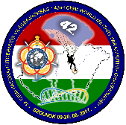
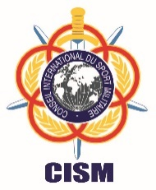
International Military Sports Council

(Hungarian Delegation)

INVITATION

42nd World Military Parachuting Championship
09-20 August 2018, Szolnok/HUNGARY

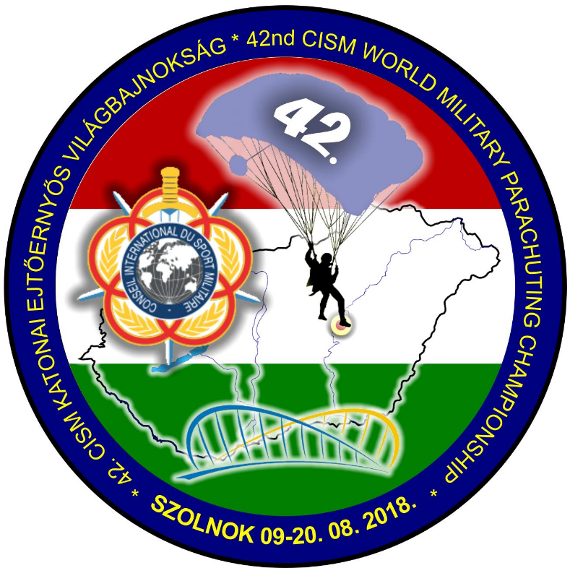

42nd World Military Parachuting Championship
09-20 August 2018, Szolnok/HUNGARY

“Friendship through Sport”

From: Colonel Zoltán ELEKI PhD

Chief of the Hungarian Delegation to CISM
Adress: 1101 Budapest, Hungária krt. 9-11.
Postal Adress: 1885 Budapest Pf. 25.
Email: eleki.zoltan@hm.gov.hu

To: See Distribution List.
Subject: 42ND World Military PARACHUTing Championship 2018

The International Military Sports Council (CISM) has entrusted the organization of the
42nd CISM World Military Parachuting Championships 2018 to the
Hungarian Defense Forces.

Thus, I have the honor of inviting a mission representing the Armed Forces of your country to participate in the Championships held in Szolnok/HUNGARY
From 09th to 20st August 2018.

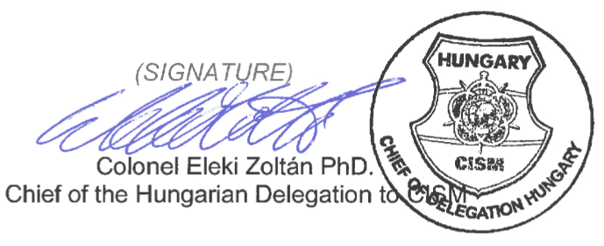

ENCLOSED:

- Distribution List;
- Program;
- General Information;
- Annex 1 - Preliminary Agreement;
- Annex 2 – Final Entry - Travel details;
- Annex 2a - Final Entry – Composition of the Mission;
- Annex 2b – Final Entry – Commitment by the Chief of Mission;
- Annex 3 – Final Entry – Final Entry Travel Details.

Distribution List

President of CISM.

Official CISM Representative.

The concerned Continental Vice-President.

CISM Secretary General.

The concerned Chief(s) of Liaison Office(s).

President and Members of CISM Sport Committee.

Representatives of the CISM Partners and Sponsors.

- To the Chiefs of Delegation of CISM Members Countries.

(See the next page, please).

To the Chiefs of Delegation of the following CISM Members Countries:
# | Nom/Name | Abbr. | # | Nom/Name | Abbr | # | Nom/Name | Abbr
1 | Afghanistan | AFG | 47 | Espagne, Royaume / Spain, Kingdom | ESP | 93 | Nigéria, R.F. / Nigeria, R.F. | NGR
2 | Afrique du Sud / South Africa | RSA | 48 | Estonie,R. / Estonia, R. | EST | 94 | Norvège, Royaume / Norway, Kingdom | NOR
3 | Albanie, R. /Albania, R. | ALB | 49 | Etats-Unis d'Amérique / United States of America | USA | 95 | Oman, Sultanate | OMA
4 | Algérie, R.P.D./ Algeria, R.P.D. | ALG | 50 | Ex-Rép. yougoslave de Macédoine /  Former Yugoslav Repulic of Macedonia | MKD | 96 | Ouganda, R. Uganda, R. | UGA
5 | Allemagne, R.F. / Germany, F.R. | GER | 51 | Finlande, R. / Finland, R. | FIN | 97 | Ouzbékistan / Uzbekistan | UZB
6 | Angola, R | ANG | 52 | France, R | FRA | 98 | Pakistan, R. islamique | PAK
7 | Arabie Saoudite, Royaume/ Saudi Arabia, Kingdom | KSA | 53 | Gabon, R. | GAB | 99 | Palestine, Etat de / Palestine, State of | PLS
8 | Argentine, R. / Argentina, R | ARG | 54 | Gambie, R / Gambia R. | GAM | 100 | Paraguay, R. | PAR
9 | Arménie / Armenia | ARM | 55 | Géorgie, R. / Georgia, R. | GEO | 101 | Pays-Bas, Royaume, The Netherlands, kKngdom | NED
10 | Autriche, R. / Austria, R. | AUT | 56 | Ghana, R | GHA | 102 | Pérou, R. / Peru, R. | PER
11 | Azerbaïdjan | AZE | 57 | Grèce, R. / Greece, R. | GRE | 103 | Philippines | PHI
12 | Bahrein, Royaume / Bahrain, Kingdom | BRN | 58 | Guatemala, R | GUA | 104 | Pologne, R. / Poland, R. | POL
13 | Bangladesh | BAN | 59 | Guinée R. / Guinea, R. | GUI | 105 | Portugal, R. | POR
14 | Barbade / Barbados | BAR | 60 | Guinée-Bissau, R. | GBS | 106 | Qatar, Etat / State of Qatar | QAT
15 | Bélarus / Belarus | BLR | 61 | Guinée Equatoriale, R | GEQ | 107 | Roumanie / Romania | ROU
16 | Belgique, Royaume / Belgium, Kingdom | BEL | 62 | Hongrie, R. / Hungary, R. | HUN | 108 | Russie, Fédération / Russia, Federation | RUS
17 | Bénin, R. / Benin, R. | BEN | 63 | Inde, R. / India, R. | IND | 109 | Rwanda, R | RWA
18 | Bolivie, R. / Bolivia, R. | BOL | 64 | Indonésie / Indonesia | IDN | 110 | Senega, R.
19 | Bosnie-Herzégovine / Bosnia Herzegovina | BIH | 65 | Iran, R. islamique I Islamic R. of Iran | IRI | 111 | Serbie / Serbia | SRB
20 | Botswana, R. | BOT | 66 | Iraq / Irak | IRK | 112 | Sierra Leone, R | SLN
21 | Brésil, R.F. / Brazil, F.R. | BRA | 67 | Irlande, R / Ireland, R.. | IRL | 113 | Slovaquie, R. / Slovakia, R. | SVK
22 | Bulgarie, R. / Bulgaria, R. | BUL | 68 | Italie, R. / Italy, R. | ITA | 114 | Slovénie, R. / Slovenia, R. | SLO
23 | Burkina Faso | BUR | 69 | Jamaïque | JAM | 115 | Soudan, R. / Sudan, R. | SUD
24 | Burundi, R. | BDI | 70 | Jordanie, Royaume hachémite/Jordania | JOR | 116 | Sri Lanka, R | SRI
25 | Cabo Verde, R. | CPV | 71 | Kazakhstan, R | KAZ | 117 | Suède, Royaume : Sweden? Kingdom | SWE
26 | Cameroun, R. | CMR | 72 | Kenya | KEN | 118 | Suisse, Conféd. / Switzerland, Confed. | SUI
27 | Canada | CAN | 73 | Kirghizistan | KGZ | 119 | Suriname, R | SUR
28 | Centrafricaine, Rep / Central African R. | CAF | 74 | Koweït, Etat / Kuwait, State | KUW | 120 | Swaziland, Royaume | SWA
29 | Chili, R. / Chile, R. | CHI | 75 | Lesotho | LES | 121 | Rép. Arabe Syrienne / Syrian Arab rep. | SYR
30 | Chine, R.P. / China, P.R. | CHN | 76 | Lettonie / Latvia | LAT | 122 | Tanzanie, Rép.-Unie / United R. Tanzania | TAN
31 | Chypre, R. / Cyprus, R. | CYP | 77 | Liban, R. / Lebanon, R. | LBN | 123 | Tchad, R./ Chad, R. | CHA
32 | Colombie / Colombia | COL | 78 | Libye / Libya | LBA | 124 | Rép. Tchèque / Czech Republic | CZE
33 | Comores, Union des / Comoros, Union of | COM | 79 | Lituanie, R. / Lithuania, R. | LTU | 125 | Thaïlande, Royaume | THA
34 | Congo, R. | CGO | 80 | Luxembourg, G.D. | LUX | 126 | Togo, R. | TOG
35 | Congo, R. D. | COD | 81 | Madagascar, R | MAD | 127 | Trinité & Tobago | TRI
36 | R.P.D. Corée / D.P.R. of Korea | PRK | 82 | Malawi | MAW | 128 | Tunisie, R. / Tunisia, R. | TUN
37 | Corée, R./ Korea, R. | KOR | 83 | Mali, R. | MLI | 129 | Turquie, R. / Turkey, R. | TUR
38 | Côte d'Ivoire, R | CIV | 84 | Malte / Malta | MLT | 130 | Ukraine | UKR
39 | Croatie, R. / Croatia, R. | CRO | 85 | Maroc, Royaume / Morocco, Kingdom | MAR | 131 | Uruguay, R. orientale | URU
40 | Danemark, Royaume / Denmark, Kingdom | DEN | 86 | Mauritanie, R. islamique | MTN | 132 | Venezuela, R. | VEN
41 | Djibouti, R. | DJI | 87 | Monaco | MCO | 133 | Viet Nam, R | VIE
42 | République Dominicaine / Dominican R. | DOM | 88 | Mongolie, Etat / Mongolia, State | MNG | 134 | Yémen, R / Yemen, R. | YEM
43 | Egypte, R. arabe / Egypt, Arabic R. | EGY | 89 | Monténégro | MNE | 135 | Zambie, R / Zambia, R. | ZAM
44 | Emirats Arabes Unis / United Arab Emirates | UAE | 90 | Myanmar | MYA | 136 | Zimbabwe, R. | ZIM
45 | Equateur / Ecuador | ECU | 91 | Namibie / Namibia | NAM
46 | Erythrée / Eritrea | ERI | 92 | Niger, R | NIG

Only CISM active member nations have the right to participate in CISM Events
(CISM Regulations, Article 1.10)

General Program of the Championship

DATE | ACTIVITY
09 August 2018 | - Arrival of Participants
10 August 2018 | - Opening Ceremony  - Preliminary Meeting  - Training Jumps
11 August 2017 | - Start of the Competitions
20 August 2018 | - Last day of Competitions  - Closing and Award ceremony, Banquet  - Cultural day
21 August 2018 | - Departures of all participants.

This program does not go into detail. The detailed schedule will be delivered to all participants upon arrival.

Composition of the Mission
- See ANNEX 2a
- Only military personnel in active duty may participate in the competitions (CISM Regulations, Art. 7.21, item A).

Access to the Location of the Competition.
- The travel cost to the host country and respective return will occur under the responsibility of the participating country.
- The organizer will ensure the transportation from the place of arrival in the host country to the place of stay if the delegation’s arrival data will be submitted to organizers until 01. July 2018. using “Annex 2” form, until 01. August 2018. using “Annex 3” form.
- The organizer will ensure the transportation during the competition.

Competition venue:
- HUN Defense Forces 86. Szolnok Helicopter Base
Address: 5008 Szolnok, Kilián u.1

Access to Szolnok city

ROAD | RAIL | INTERNATIONAL AIRPORT | MILITARY AIRPORT
Via Highway M7, and M5  Via Motorway 4 exit Szolnok | Railway Station Szolnok | Budapest Liszt Ferenc International Airport (BUD) ~ 100km | Szolnok Military Airport (LHSN)

Return of forms
- On the Preliminary entry form, the participating mission shall indicate a valid and operated phone/mobile phone and fax number as well as an email address in case the organizing committee needs to contact them.
- All names mentioned in agreements and in any forms, must be written in Latin letters as stated in the passport.

Conditions of Stay
- Board and lodging will be at the expenses of the Organizer.
- Participants who ask for services not covered by the Organizer, such as telephone calls, drinks, laundry etc. must pay the respective extra expenses.
- Any costs associated with the stay of missions before 09th or after 21st August 2018 must be paid by the respective nations.
- Additional people will not be accepted without official written permission of the Organizer.
- The Organizer will provide the medical assistance. Medical emergencies (first aid) will be the responsibility of the Hungarian Defence Forces. The Hungarian Defence Forces will provide medical support for all scheduled competitions. The Hungarian Defence Forces will not be responsible for any advanced medical expenses, to include hospital stays, surgical procedures, and/or other medical care beyond first aid.
- All participants must travel with their own inherent medical coverage. Special medical treatment is under the responsibility of the participating nations.

Regulations of the Championship.
- The competition will be organized in accordance with the most recent regulations of the CISM Parachuting Regulations and CISM Regulations, Edition July 2017. http://www.milsport.one
- See Parachuting Regulations edition 2018 document at: http://www.milsport.one/site/170818_cism_pararules_2018pdf-en-15869-2.html
- The Championship includes Accuracy, Formation Skydive and Style competitions.
- The official working language for this Championship is English.

Anti-doping
- Anti-Doping tests will be conducted in accordance with the CISM Regulations – Chapter IX, CISM Anti-Doping Rules, the concerned CISM Sports Regulations, the concerned International Federation Rules, and all WADA rules, mainly the World Anti-Doping Code, and the International Standard for Testing.
- The number and type of tests, as well the athletes to be tested shall be determined by the CISM Anti-Doping Commission. These procedures will follow the concerned CISM Test Distribution Plain (TDP).
- In case an athlete has a Therapeutic Use Exemption (TUE), the Chief of Delegation should send this TUE to the CISM GS until 30 days before the Opening Ceremony. This TUE will be submitted to the TUE Commission to analysis and further approval.

Uniforms
- Military uniforms (Summer Uniform) are mandatory for official ceremonies, especially for opening and closing ceremony of the Championship.

Customs and Visa Procedures.
- Information concerning passports, visas and vaccinations can be obtained from the Hungarian Embassy in your country (Invitation is present at Hungarian Embassy).

Weather Conditions
- The weather in August can range from a daily high of 30° - 37° Celsius to a daily low of 20°- 25° Celsius. The possibility of sunshine is high and of rain is minor. Average wind is NW, 2-5 m/s

Additional required items
- National Anthem (CD/USB drive)
- National flag (according to regulation 3.3.2.C):
- size 1,0m x 1,5m for a 6m flagpole and
- size 1,5m x 2,25m (special for parachuting show)
- Additional data:
- photo of delegation members:
- taken in military uniform
- showing the full face from the front 4x6 cm size photo at high resolution
- no less than 300 dpi
- titled “rank, family name, nation”, e. g. Major Kiss Hungary
- copy of valid passport
by e-mail (see official correspondence below) not later than final entry deadline.

Registration Forms Deadlines.
Preliminary Agreement (Annex 1) 01 May 2018
Final Entry (Annex 2, Annex 2a) - Travel Data and Composition of the Mission
01 July 2018
Final Entry (Annex 2b) – Commitment by the Chief of Mission 01 July 2018
Final Entry (Annex 3) - Final Entry Travel Details 01 August 2018
- The participating mission should inform both valid phone and fax numbers in the Preliminary agreement form, as well as their email address in case of the organizing committee needs to get in contact.

Aircraft
- PC-6 Pilatus (SVN) airplanes and AS-350, Mi-8/17, Mi-24 (HUAF) helicopters.
- Door sizes relevant to formation skydive:
Mi-8/17: Side Door: 1375 mm (height) x 825 mm (width)
Back Door (Ramp): 1820 mm (height) x 2340 mm (width)
BACK DOOR WILL BE USED FOR FORMATION SKYDIVE!
Mi-24: Left side door: 1115 mm (height) x 1180 mm (width)
Right side door: 1180 mm (width) x 1050 (height)
RIGHT SIDE DOOR WILL BE USED FOR FORMATION SKYDIVE!

Correspondence.
- For official correspondence concerning the 42th CISM World Military Parachuting Championships, please contact: (Address: 5008 Szolnok Kilián út 1., Phone: Col. Tamás BALI +36704594603, LtCol. Tibor BALLA +36304962324, Email: cism42wmpc@gmail.com, Website: under construction)

ANNEX 1
42nd CISM World Military Parachuting Championship

PRELIMINARY AGREEMENT
To be returned before 01 May 2018.
Contact of the Organizing Committee: cism42wmpc@gmail.com
with copy to : - President of CISM Parachuting Committee

NATION :

TOTAL NUMBER of PARTICIPANTS:
 | Officials  (max. 3) | Athletes  (max. 13) | CSC member (1) | Referees  (min. 1) | Total
Men
Women
Total
Name of qualified Judge:
(mandatory, a form without a judge is not valid) ................................................................
Type of judge’s license (ASF/ CISM and/or FAI cat1 ):.........................................
Means of transport (Will You use HUN transportation or do You intend to use Your vehicle?): …………………………………………………………………….………....
ACCOMODATION (Will You use organizer provided or do You intend to accommodate Your delegation at local Hotel /at Your own expense/?):…………………………….......

DATE:________________ __________________________________
SIGNATURE OF CHIEF OF DELEGATION
RANK/NAME:
_________________________________
Your Contact | Rank/Name
Your Contact | Phone
Your Contact | Fax
Your Contact | E-Mail

ANNEX 2
42nd CISM World Military Parachuting Championship

FINAL ENTRY – TRAVEL DATA
To be returned before 01 July 2018.
Contact of the Organizing Committee: cism42wmpc@gmail.com
with copy to : - President of CISM Parachuting Committee

NATION :

 | PLACE | DATE | FLIGHT Nr  TRAIN Nr  BUS Nr | TIME
ARRIVAL
DEPARTURE
Note: if some travel details are missing or the delegation is not arriving together, the Final Entry form needs to be submitted in time with date of arrival and means of transport. Flight# can be sent to the OC with Annex 3 in a separate message.

Means of transport (Will You use HUN military transportation or do You intend to use Your vehicle?): …………………………………………………………………………

DATE:________________ __________________________________
SIGNATURE OF CHIEF OF DELEGATION
RANK/NAME:
_________________________________

Your Contact | Rank/Name
Your Contact | Phone
Your Contact | Fax
Your Contact | E-Mail

ANNEX 2a to Final Entry

FINAL ENTRY - COMPOSITION OF THE MISSION
To be returned before 01 July 2018.
Contact of the Organizing Committee: cism42wmpc@gmail.com
with copy to : - President of CISM Parachuting Committee

NATION :

Year of birth for athletes only
# | Function | Rank | Sex  M/F | Given name | Surname (family name) |  | YOB | Participation in
 | Chief of Mission |  |  |  |  |  |  | Accuracy | Style | Formation
 | Team leader |  |  |  |  |  |  | Accuracy | Style | Formation
 | Judge |  |  |  |  |  |  | Accuracy | Style | Formation
 | Coach |  |  |  |  |  |  | Accuracy | Style | Formation
Competitors: |  |  |  |  |  |  |  | Accuracy | Style | Formation
 | freefall cameraman* |  |  |  |  |  |  |  |  | x
 | Male athlete  (in jumporder team accuracy) |  | M
 | Male athlete  (in jumporder team accuracy) |  | M
 | Male athlete  (in jumporder team accuracy) |  | M
 | Male athlete  (in jumporder team accuracy) |  | M
 | Male athlete  (in jumporder team accuracy) |  | M
 | Female athlete  (in jumporder team accuracy) |  | F
 | Female athlete  (in jumporder team accuracy) |  | F
 | Female athlete  (in jumporder team accuracy) |  | F
 | Female athlete  (in jumporder team accuracy) |  | F
 | Female athlete  (in jumporder team accuracy) |  | F
additional
Junior athlete (M/F)
 | CPC Member**
*CISM Parachuting rules 3.3.1.D applies ** if not appointed in a function 1 - 15
In strict compliance with applicable CISM Reg. 7.21, I, the undersigned Chief of Delegation, hereby officially confirm that all athletes representing my nation in the CISM event are on active duty in my nation’s Armed Forces. I understand that sanctions may be imposed against my nation, my mission, my team, individual athletes, or myself for violation of this provision (CISM Reg.)
DATE:________________ __________________________________
SIGNATURE OF CHIEF OF DELEGATION
RANK/NAME:
_________________________________
ANNEX 2b to Final Entry

FINAL ENTRY - Commitment by the Chief of Mission
To be returned before 01 July 2018 or signed by CoM on site
Note: This form is to be signed by the Chief of Mission
The undersigned Chief of Mission of
NATION :

The undersigned, Chief of Mission declare that he has read the CISM Regulations and moreover understood the following prescriptions:

Article 1.10. RIGHTS OF MEMBER NATIONS
- Active member nations have the right to:
2. Be invited to all CISM Championships.
- Inactive member nations have the same rights as active member nations except that:
2. They do not participate in any CISM event until they have met their financial obligations.
Article 7.21. PARTICIPATION - MILITARY STATUS
A. Only military personnel on active duty in Armed Forces may take part in competitions organized by CISM.
B. No one may be recalled to active duty in the Armed Forces for the purpose of participating in a CISM competition. In the case of an intermittent military service, the athletes regularly recalled may not take part in CISM competitions, under any circumstances, if more than 18 months have elapsed between this recall and the end of their last call to arms.
C. Exceptions to the above may be authorized by the General Assembly, upon recommendation of the Board of Directors.
D. All military participants in a CISM event shall be in possession of proper documentation which signifies active military service of the member nation he represents. The documentation can be:
1. A valid military identity card for those athletes who are authorized to present their military identity cards abroad,
2. A form of verification (in English and/or French) of military status accompanied by a passport.
E. By signing the final entry, the Chief of Delegation confirms the military status of the participating athletes. If there are last minute changes in the participation of the athletes, the verification file may be signed by the Chief of Mission, but shall be confirmed by the Chief of Delegation by official letter.
F. If one of these documents is not available, participation is refused.

Article 7.24. PARTICIPATION OF AN INACTIVE MEMEBR NATION
Athletes or teams of an inactive member nation may not participate in any CISM event (art 1.10 of the Regulations).
Article 7.30. CHIEF OF MISSION
- Chief of Mission
- Chiefs of Mission shall be familiar with CISM regulations.
- Missions must not only participate or be present at sports events, they are also required to participate in information conferences on CISM, study days, commemorative and cultural events and ceremonies organized by the host nation.
- Conduct of a mission
- The Chief of Mission is responsible for the behavior of his team in sports and general discipline. He shall ensure that members of his mission respect the rules and directives prescribed by CISM and organizers of the championship. The respect of schedules is particularly important as they form the basis for the effective conduct of competitions and ceremonies.
- The Chief of Mission shall also enforce the rules concerning behavior and dress during the ceremonies. He plays an important role in promoting the CISM spirit among his mission, a spirit represented by friendly attitude towards other missions, courtesy towards organizers and fair-play in competition.
Article 8.6. ABSENCE OF A MISSION WITHOUT NOTIFICATION
If a mission which submits a preliminary agreement and/or final entry is absent without notifying the host nation in time, a sanction will be imposed (CISM Regulations,
Art. 1.12).
Article 8.17. RULES OF STAY
A. General
1. The Chiefs of Mission are responsible for the discipline of their mission. The missions fall under the jurisdiction of the organizing nation. During events, all athletes present on the playing fields are equal before the jury, the referees and to themselves. No one may use his rank to impose his views on sports matters.
2. Civilian members of the missions shall conform to the discipline accepted by all other participants.
B. Military uniforms
1. Unless otherwise approved by the Official CISM Representative, all participants shall wear military uniform during official ceremonies such as the opening and closing ceremonies and medal-awarding ceremonies. Individuals without proper uniform will not be allowed to participate in the championship.
2. The presentation of medals takes place, in principle, during the closing ceremony. The presentation of medals may be done in sports uniform, if for organizational reasons it is not possible to wear military uniforms. This is the case e.g. when the presentation immediately follows a championship sports event. Sports uniforms shall respect the corresponding national criteria (training suit, sports shoes, etc.) Displaying the national flag on the podium by the recipient (athlete or team) at a medal awarding ceremony is forbidden. Individuals failing to respect these prescriptions shall not receive their medal(s) during the official ceremonies.
C. Forbidden actions
1. In conformity with the statutes and traditions of CISM, any political or religious propaganda during a CISM event, in particular the dissemination of documents, pictures, brochures, reviews, etc. is strictly forbidden.
2. Any contravention shall result in the exclusion of the mission from further competition and may result in additional sanctions (Regulations Art. 1.12).

DATE:________________ __________________________________
SIGNATURE OF CHIEF OF MISSION
RANK/NAME:
_________________________________

Annex 3 to final entry – travel details
ANNEX 3 to Final Entry

FINAL ENTRY Travel Details
To be returned/amended NOT LATER THAN 01 August 2018.
Contact of the Organizing Committee: cism42wmpc@gmail.com
with copy to : - President of CISM Parachuting Committee

NATION :

Number of pax |  | PLACE | DATE | Means of transport | FLIGHT Nr  TRAIN Nr  BUS Nr | TIME
 | ARRIVAL
 | DEPARTURE
If the whole mission is not travelling together, specify role 1-18 from Annex 2a for different arrival
 | ARRIVAL
 | DEPARTURE
 | ARRIVAL
 | DEPARTURE
Note: if some travel details are missing, the Final Entry form needs to be submitted in time with date of arrival and means of transport. Flight# can be sent to the OC in separate messages.

DATE:________________ __________________________________
SIGNATURE OF CHIEF OF DELEGATION
RANK/NAME:
_________________________________

